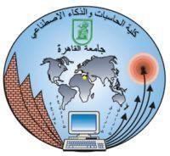

Faculty of Computers and Artificial Intelligence Cairo University

OOP Assigment TA: Aya Tarek

SnekyPhoto-Image

proccsing application

Submitted to:

**Dr. Mohamed Elramly**

Prepared by:

**Team Leader:** Mahmoud Elsayed (20240548)

1. Adham Tamer Abdelmaougoud (20240067)(S26)
2. Mahmoud Elsayed Musa (20240548)(S27)
3. Youssif Elnahas (20240699)(s27)

Githup: https://github.com/birdbox219/SnekyPhoto

**Overview of the "SnekyPhoto" Image Processing Project**

Our project, which we named "SnekyPhoto," is a simple image processing application we developed as Part A1-CS213 course. The whole idea is to let a user open any image from their computer and start modifying it with a wide range of filters and effects that we programmed ourselves, all through a command-line interface (the console).

**What It Does & How It Works**

It's pretty straightforward to use. When you launch the program, it first asks you to load an image. Once the image is ready, a menu appears listing all the available filters you can apply.

We implemented about 18 different filters. There are basic ones, like converting an image to **Black and White** or **Grayscale**, or **Inverting** its colors. We also added more artistic filters, like an **Oil Painting** effect or giving it an **Old TV Screen** look. Of course, there are also essential tools to manipulate the image dimensions, allowing you to **Crop** a specific area, **Resize** the whole image, or even **Merge** two images together.

A key feature we focused on was the user experience, which is why we implemented an **Undo and Redo** system. If a user applies a filter and doesn't like the result, they can easily revert the last action. If they change their mind again, they can redo it. At any point during the process, the user can save their edited work as a new image file, choosing the name and extension they want.

**Who Worked On This?**

This project was a course assignment for CS213, supervised by **Dr. Mohamed Elramly**.

We worked as a team of three and divided the tasks to cover as many filters as possible:

* **Adham Tamer**
* **Mahmoud Elsayed**
* **Youssif Elnahs**

Each of us was responsible for a specific set of filters, while we all collaborated on the core administrative features like the save/load system, the undo/redo logic, and the main menu.

The main goal of this assignment was to apply what we were learning in a practical way. It was a great opportunity to understand how to manipulate images at the pixel level, build a complete application with functional logic and most importantly, learn how to work as a team to deliver a finished product.

An over view of system Design :

Snap shots from our git hup repo :

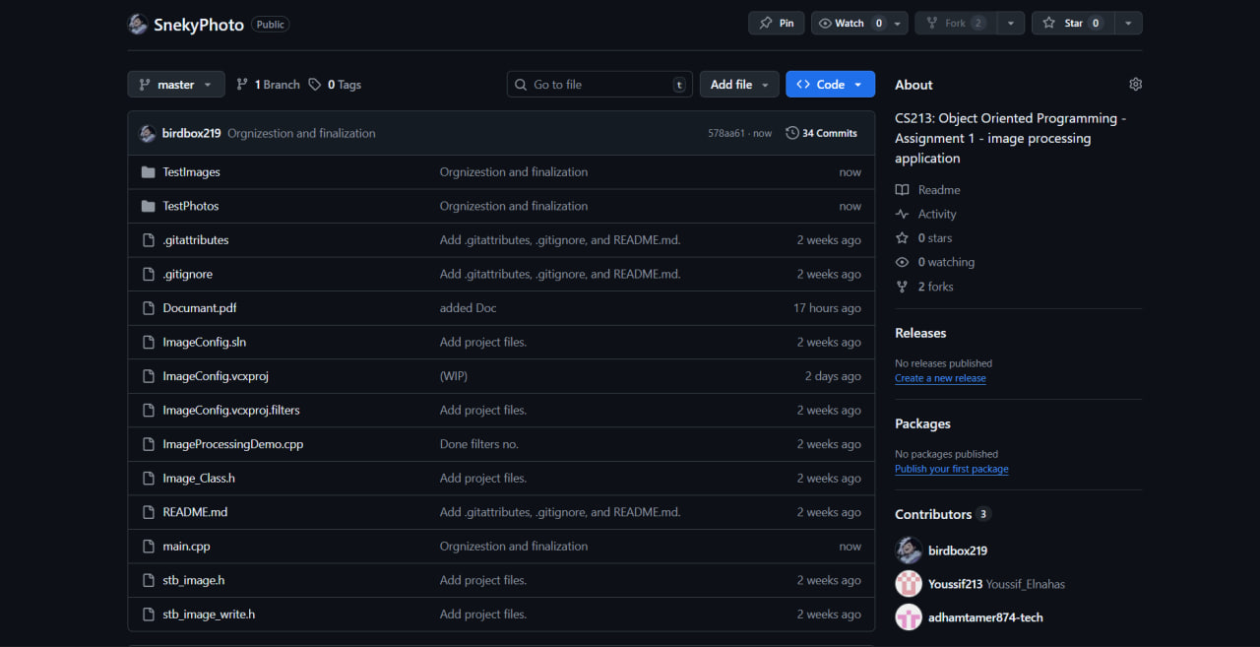

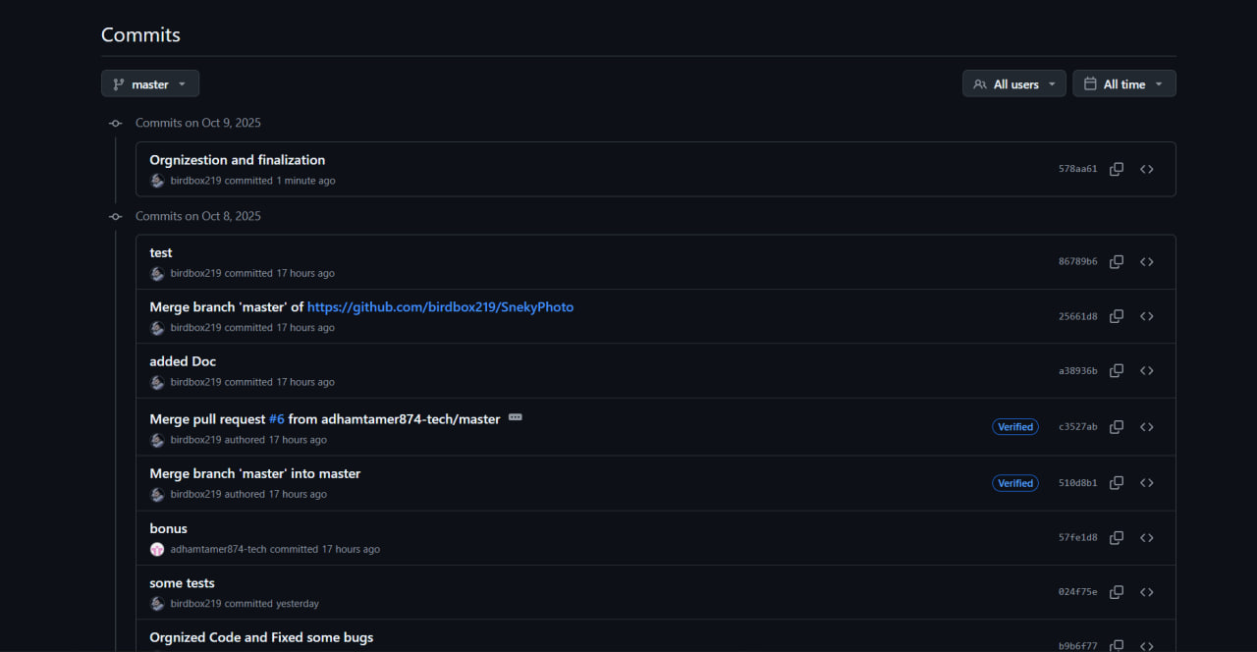

Screen Shot from the Program : 